

Table of Contents

Installation Guide 7

Use System Installer 7

Opening the Application 12

Connecting the Database 13

Uninstalling the Application 16

General Information 19

Control Functionality 19

Checkbox 19

Data Grid 19

Date Picker 20

Drop-down 22

Radio Button 22

Save File Dialog 24

Searchable Drop-down 26

Textbox 27

Time Picker 28

Toggle 31

Development Account Login Information 32

Refresh Icon 33

Login Screen 35

Log In 35

Edit Database Settings 37

Home 39

Log Out 39

Volunteers Tab 40

General 40

Page Summary 40

Navigate to General Page 40

Add Volunteer 41

View Volunteer Information 43

Edit Volunteer Information 44

Demographics 46

Page Summary 46

Navigate to Demographics Page 46

View Specific Volunteer Information 47

Edit Volunteer Demographic Information 48

Update Volunteer Name 50

Set Volunteer Inactive 52

Financials 56

Page Summary 56

Navigate to Financials Page 56

Edit Volunteer Financial Information 57

Change Date 60

Classrooms 61

Page Summary 61

Navigate to Classrooms Page 61

Add Classroom 62

Edit Classroom 64

Delete Classroom 66

View Volunteer’s Classrooms 67

View School’s Classrooms 67

Export Classrooms 68

Child Assignments 70

Page Summary 70

Navigate to Child Assignments Page 70

Edit Student Assigned to Volunteer 71

Assign Student to Volunteer 74

Add Student Condition 76

Add Student Need 79

Remove Student from Volunteer 82

View Volunteer’s Assigned Students 84

View Volunteer’s Assigned Students in Specific Classroom 85

Activity Log 86

Page Summary 86

Navigate to the Activity Log 86

View Volunteer’s Activity Log 87

View Log Entries within Specific Dates 88

Add Log Entry 89

Edit Log Entry 91

Delete Log Entry 93

Export Report to Excel 95

Schools Tab 97

All Schools 97

Page Summary 97

Navigate to the All Schools 97

Add New School 98

Edit Specific School 100

Edit School Hours 103

View Only Active Schools 106

Export All Schools General Information to Excel 107

Export All Cite Visitation Sheets to Word 108

Export Specific School’s Cite Visitation Sheets to Word 109

Per School 110

Page Summary 110

Navigate to Per School Page 110

Edit Specific School 111

Make School Inactive 114

Edit School Times 116

Delete School 118

View Specific School Information 119

Export Specific School Information 120

Finance Tab 122

General 122

Page Summary 122

Navigate to General Page 122

View Specific Year’s Cost Share Data 123

Edit Quarterly Cost Share Amount 126

Delete Quarterly Cost Share Amount 128

View Specific In-Kind Expense Type 129

View In-Kind Expense Year Range 129

View Type Year 129

Filter By Donor 130

Add New In-Kind Expense 131

Edit In-Kind Expense 133

Meal and Transport 135

Page Summary 135

Navigate to Meal and Transport Page 135

View Specific Date’s Information 136

View Specific Volunteer's Meal and Transportation Information 136

Edit Meals and Transportation Information 137

Export Meals and Transport Information to Excel 139

PTO 141

Page Summary 141

Navigate to PTO Page 141

View Specific Date’s PTO Information 142

View Specific Volunteer PTO 143

Edit Volunteer PTO Information 144

Export PTO Information to Excel 146

Fiscal Year 148

Page Summary 148

Navigate to Fiscal Year 148

View Specific Year Range 149

View Category Breakdown 150

Export Category Breakdown 151

View Specific Date in Category Breakdown 153

Export Quarterly Fiscal Year Information 154

Grant Year 155

Page Summary 155

Navigate to Grant Year Page 155

View Specific Year Range 156

View Category Breakdown 157

Export Category Breakdown 158

View Specific Date in Category Breakdown 160

Export Quarterly Grant Year Information 161

Reports Tab 162

Report Builder 162

Page Summary 162

Navigate to Report Builder Page 162

Build Custom Report 163

Add Preset Report 167

Use Preset Report 169

Edit Preset Name 170

Delete Preset 171

Annual Check 172

Page Summary 172

Navigate to Annual Check Page 172

View Current Volunteers 173

View Volunteer’s Missing Documentation 173

View Volunteer’s Check Information 174

Volunteer Information 175

Page Summary 175

Navigate to Volunteer Information Page 175

Edit Volunteer Information 176

View Specific Volunteer 179

View Volunteers Based on Status 180

Export Volunteer Information to Excel 181

Users Tab 183

Users 183

Page Summary 183

Navigate to the User Tab 183

Add New User 184

Edit User Info 186

Delete User 189

Admin Tasks 190

Page Summary 190

Navigate to the Admin Tasks Tab 190

Add Item to Category 191

Add Temporary Information Field 192

Delete Category Item 194

Recover Deleted Volunteer 196

Edit Student Needs 197

Delete Student Needs 199

Edit Student Conditions 200

Delete Student Conditions 202

Edit Rates 203

Set Grant Year Stipend 204

Delete All Students Assigned to Volunteers 205

# Installation Guide

## Use System Installer

1. Open the GEMWindowsInstaller Setup Wizard on the Windows computer you’d like to install the application.  
   Graphical user interface, application, Word

   Description automatically generated
2. Click the Next button to continue.   
   Graphical user interface, text, application, email

   Description automatically generated

**NOTE: Click the Back button to return to previous steps of the installer or cancel the installation with the Cancel button.**

1. Click the Browse button to select an installation location. By default the application is installed to <C:\Program Files\SVSU CS Capstone 2023\Grandparent Education Management System (GEM)\>.  
   Graphical user interface, text, application, email

   Description automatically generated
2. Click the Disk Cost button to ensure your computer has enough storage space for the application.  
   Graphical user interface, text, application, email

   Description automatically generated
3. Ensure that the required disk space is less than the available space.  
   Graphical user interface, text, application

   Description automatically generated
4. Choose to install the application for every profile computer, or just the user signed into the computer.

**Note: Check for a pop-up asking you to confirm the app can make changes to your device if the installation seems stuck on this screen.**

1. Click the Next button to start installing the application.  
   Graphical user interface, text, application, email

   Description automatically generated
2. Click the Close button to close the Setup Wizard when the installation is complete.  
   Graphical user interface, text, application, email

   Description automatically generated

## Opening the Application

1. Open the “C_FGMS.UI” file, which has the Application filetype. It is in the destination folder you specified in the Setup Wizard.  
   Graphical user interface, text, application

   Description automatically generated

## Connecting the Database

1. If this is the first time the application is opened, you will be prompted to connect the database.  
   Graphical user interface, text, application

   Description automatically generated
2. Enter the database information.

**Note: GEM Database Information**

**Server Name: sql-read-01.saginawcounty.com**

**Database: FGMS_Data**

**Username: COA-FGMS**

**Password: C0Mm1$sion@G3**

1. Click the Test Connection button to ensure the information is correct.  
     
   Graphical user interface, text, application

   Description automatically generated  
     
   .

**Note: A message will appear to let you know if the connection succeeded or failed.**

1. Click the Save button to continue, once the database connection is successful.  
   Graphical user interface, text, application

   Description automatically generated

# Uninstalling the Application

1. Open the Control Panel from your computer’s search bar.  
   A screenshot of a computer

   Description automatically generated with medium confidence
2. Click on “Uninstall a program”  
   Graphical user interface, text, application

   Description automatically generated
3. Choose the Grandparent Education Management System

1. Click the Uninstall button.

# General Information

## Control Functionality

### Checkbox



#### Select Checkbox

1. Click the box next to the label to select the value.



#### Deselect Checkbox

1. Click the box next to the label to deselect the value.



### Data Grid

#### Sort Data Grid

1. Click Title Label for category to sort by.

### Date Picker



#### Select Date

1. Click the Calendar icon.



1. Use the left and right arrows to scroll to the correct month for the date.

1. Click the correct date number for the date.

**Note: Type a time into the Time Picker to set the time without using the clock.**

#### Clear Date Picker

1. Click the Delete button.

### 

### Drop-down

#### Select Value

1. Click the Down arrow.

1. Select item from list of items.

### Radio Button



#### Select Radio Button

1. Click the circle next to the label to select the value.



#### Deselect Radio Button

1. Click the circle of a different radio button in the group of buttons.

### 

### Save File Dialog

#### Save File

1. Navigate to the location where you want to save the file.

1. Type in file name.

1. Click the Save button.

### 

### Searchable Drop-down

#### Select Item from Drop-down

1. Click the Down arrow.

1. Select item from list of items.

#### Search for Item in Drop-down

1. Click into the field.

1. Type in the value you’re searching for.

1. Click the Enter key to select value.

#### Clear Selected Item

1. Click the Clear icon.

### Textbox

#### Enter Text

1. Click into the field.



1. Type text into field.



### 

### Time Picker

#### Select Time

1. Click the Clock icon.

1. Select AM or PM.

1. Select the hour from the outer edge of the clock.

1. Click and drag the minute hand to the correct value.

1. Click the Confirm button.

**Note: Type a time into the Time Picker to set the time without using the clock.**



### 

### Toggle



#### Enable Toggle

1. Click the Toggle switch.



#### Disable Toggle

1. Click the Toggle switch.



## 

## Development Account Login Information

The development account exists as a backup in the case that all existing administrative accounts are deleted from the system. It can be used to add an administrative account back into the system.

**Username**: svsu.developer@svsu.edu

**Password**: a,f=9o(myt$$4GWUob()@

## Refresh Icon

On any pages with a refresh icon visible, the icon can be clicked to reload the data from the database.

1. Click the Refresh icon.

**NOTE:**

**1) If at any point when using the system, you do not see the correct, most updated data you think you should be seeing, try refreshing first before anything else.**

**2) If at any point you select a row in a data grid and you want to un-select it, click the Refresh icon.**

# Login Screen

## Log In

**Note: If it is the first time you are opening the program, you will see a popup saying you need to configure your database setup. If you see this, please reference the installer guide on page 13 to configure your database.**

1. Enter in your email and password credentials, once the database is correctly configured.

1. Click Login.

## 

## Edit Database Settings

* 1. Graphical user interface, text, application

     Description automatically generatedClick the Database Settings button.
  2. Update the editable information.

1. Click the Test Connection icon.

1. Click the Save icon after testing the database connection.

# Home

## Log Out

1. Click the Log Out icon.

# Volunteers Tab

## General

### Page Summary

This General Tab allows you to view, edit, add, or delete active and inactive volunteer’s data.

### Navigate to General Page

1. Click on the Volunteers Tab

1. Click the General Tab.

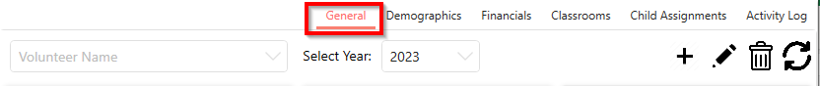

### 

### Add Volunteer

1. Click the Add icon to add a volunteer.

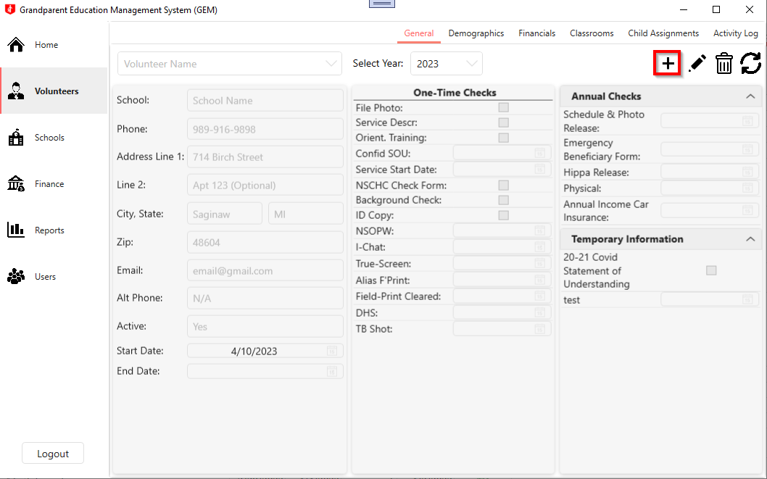

1. Enter all the volunteer’s information. All enterable fields are marked below.

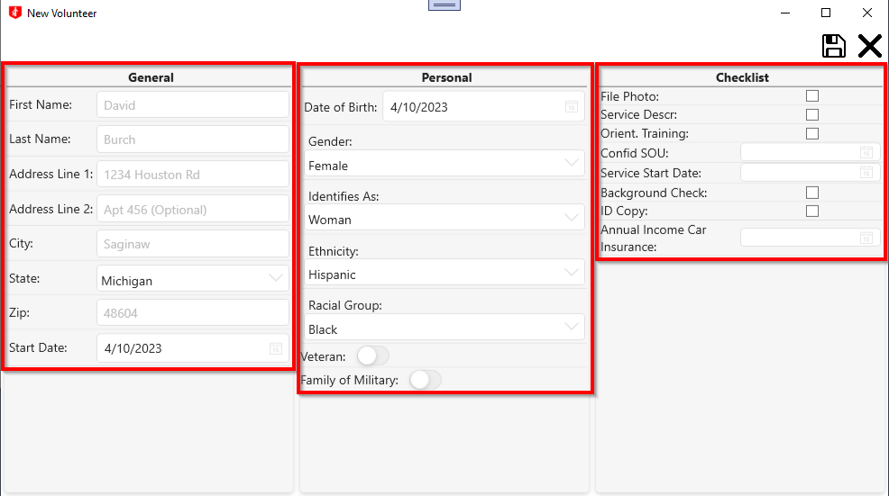

1. Click the Save icon to save your changes.

**Note: Click the Cancel icon to discard the changes and exit edit mode.**

**Click the Confirm Icon to** **discard the changes and exit edit mode.**

**Click the Cancel Icon to prevent the changes from being deleted.**

### View Volunteer Information

1. Select a volunteer’s name from the Volunteers drop-down to view their information.

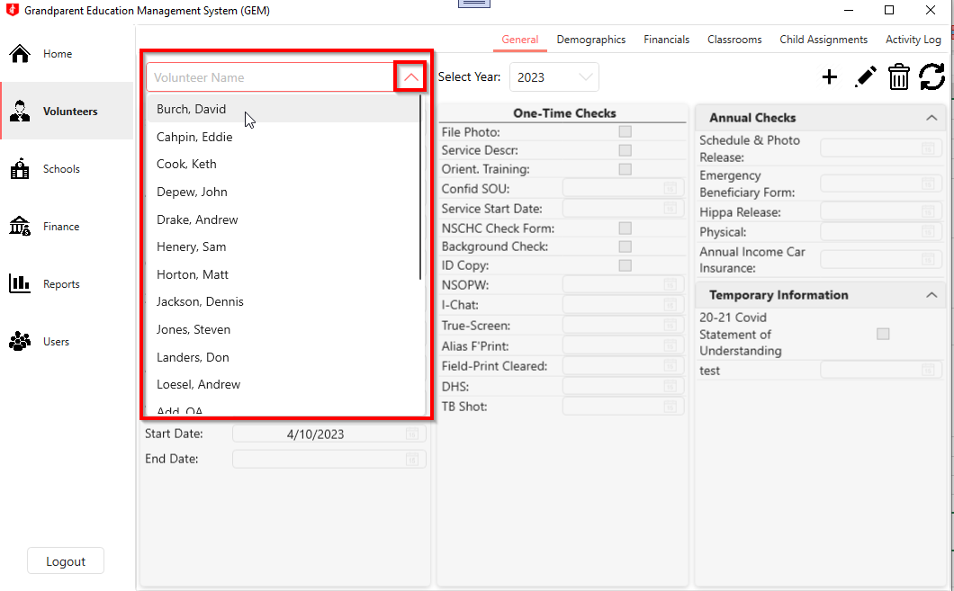

### Edit Volunteer Information

1. Click the Edit icon to update the volunteer’s information.

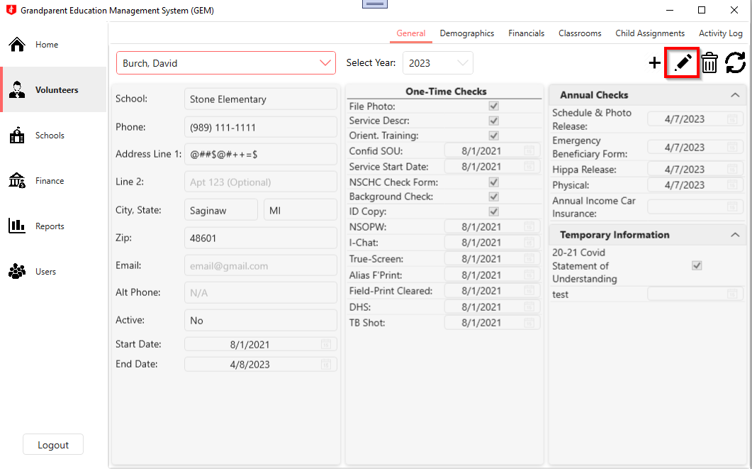

1. Update any of the editable fields outlined below. 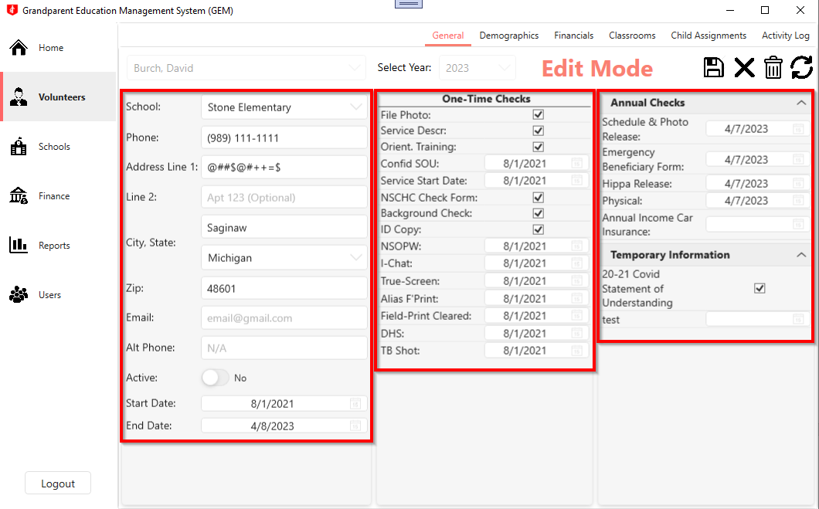
2. Click the Save icon to persist your changes.

**Note: Click the Cancel icon to discard the changes and exit edit mode.**



**Click the Confirm Icon to** **discard the changes and exit edit mode.**

**Click the Cancel Icon to prevent the changes from being delete.**

## 

## Demographics

### Page Summary

This page allows you to view or edit an active or inactive volunteer’s demographic information.

### Navigate to Demographics Page

1. Click the Volunteers Tab

1. Click the Demographics Tab

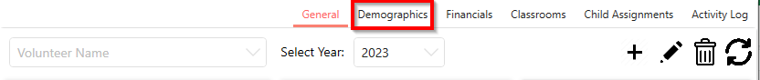

### View Specific Volunteer Information

1. Select a volunteer whose demographics you’d like to view.

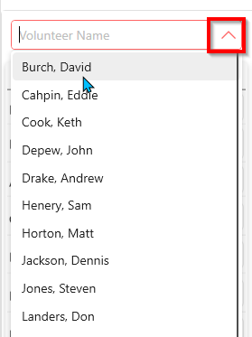

### 

### 

### Edit Volunteer Demographic Information

1. Select the volunteer whose demographics you’d like to edit.



1. Click the Edit icon.

1. Update any of the editable fields outlined below.

1. Click the Save icon to persist the edits made to the volunteer’s demographic information.



**Note: Click the Cancel icon to discard the changes and exit edit mode.**

**Click the Confirm Icon to** **discard the changes and exit edit mode.**

**Click the Cancel Icon to prevent the changes from being delete.**

### 

### Update Volunteer Name

1. Select the volunteer whose demographics you’d like to edit.

1. Click the Edit icon.

1. Click Down icon.

1. Update editable fields.

1. Click Save icon.

**Note: Click the Cancel icon to discard the changes and exit edit mode.**

**Click the Confirm Icon to** **discard the changes and exit edit mode.**

**Click the Cancel Icon to prevent the changes from being delete.**

### Set Volunteer Inactive

1. Select the volunteer to edit.

1. Click the Edit icon.

1. Click the Status toggle to set the volunteer inactive.

1. Set the Separation Date. By default, this will be set to the current date.

1. Select the volunteer’s separation reason from the Reason drop-down.

1. Click Save icon.

**Note: Click the Cancel icon to discard the changes and exit edit mode.**

**Click the Confirm Icon to** **discard the changes and exit edit mode.**

**Click the Cancel Icon to prevent the changes from being delete.**

### 

## Financials

### Page Summary

This page allows you to view and edit a specific volunteer’s hours, PTO & stipends, and meal and transportation data for a specific month and year.

### Navigate to Financials Page

1. Click the Volunteers Tab.

1. Click the Financials Tab.

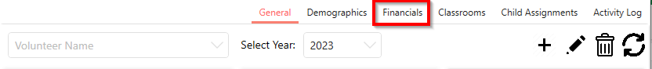

### Edit Volunteer Financial Information

1. Select a volunteer from the Volunteer Name drop-down.

1. Click the Edit icon to update information.

1. Update the editable information.

**NOTE: Click the PTO Eligibility toggle to change a volunteer’s pto eligibility.**

1. Click the Save icon when doneGraphical user interface, application

   Description automatically generated

**Note: Click the Cancel icon to discard the changes and exit edit mode.**

**Click the Yes button to** **discard the changes and exit edit mode.**

**Click the No button to prevent the changes from being delete.**

### Change Date

1. Select the year from the Year drop-down.

1. Select the month from the Month drop-down.

## Classrooms

### Page Summary

This page allows you to add, edit, delete, and export classrooms as well as view specific volunteer’s classrooms and specific schools’ classrooms.

### Navigate to Classrooms Page

1. Click the Volunteers Tab.

1. Click the Classrooms Tab.

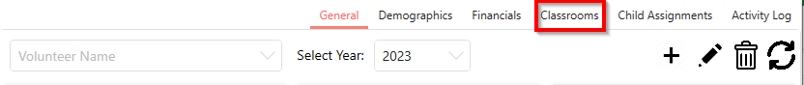

### 

### Add Classroom

1. Click Add icon.

1. Fill out all the classroom information. All required fields are outlined below.

1. Click Save icon.

**Note: Click the Cancel icon to discard the changes and exit add mode.**

**Click the Yes button to** **discard the changes and exit add mode.**

**Click the No button to prevent the changes from being delete.**

### Edit Classroom

1. Select entry to edit.

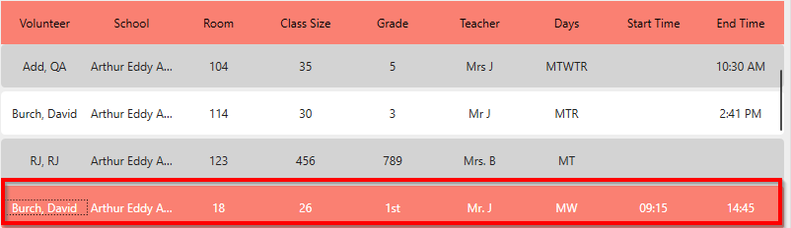

1. Click Edit icon.

1. Update any of the editable fields outlined below.

**Note: Click the Edit Time toggle and then enter the new times to update the Start Time and End Time.**

1. Click Save icon.

**Note: Click the Cancel icon to discard the changes and exit edit mode.**

**Click the Yes button to** **discard the changes and exit edit mode.**

**Click the No button to prevent the changes from being delete.**

### 

### Delete Classroom

1. Select entry to delete.



1. Click the Delete icon.

1. Click the Yes icon.

**Note: Click the No icon to prevent the entry from being deleted.**

### View Volunteer’s Classrooms

1. Select a Volunteer from the drop-down.

### View School’s Classrooms

1. Select a School from the drop-down.

### 

### Export Classrooms

1. Select the Volunteer to export logs from a specific person. If not logs for all volunteers will be exported.

1. Select the School Name to export logs from a specific school. If not logs for all schools will be exported.

1. Click Export icon.

1. Click Save icon.

**Note: Click the Cancel icon to discard the report.**

## Child Assignments

### Page Summary

This page allows you to add new students to a volunteer, edit existing students and delete students from a volunteer. This page also displays the classroom size, number of kids assigned, the kids grade level and the age breakdown of the students.

### Navigate to Child Assignments Page

1. Click the Volunteers Tab

1. Click the Child Assignments Tab

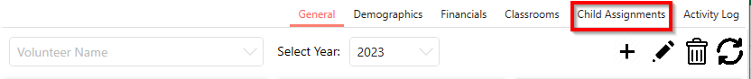

### Edit Student Assigned to Volunteer

1. Select the volunteer from the Volunteer Name drop-down whose student assignment you want to edit.

1. Select the student’s room number from the Room Number drop-down.

1. Select the student you want to edit.

1. Click the Edit icon.

1. Update the editable information outline below.

1. Click the Save icon.

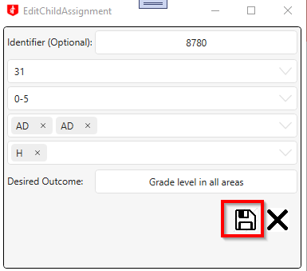

**Note: Click the Cancel icon to discard the changes and exit edit mode.**

**Click the Yes button to** **discard the changes and exit edit mode.**

**Click the No button to prevent the changes from being delete.**

### Assign Student to Volunteer

1. Click the Add icon.

1. Fill out all the student’s information. All required fields are outlined below.

**NOTE: The Identifier is optional and will be automatically generated if nothing is entered.**

1. Click the Save icon to assign the student to the currently selected volunteer.

**Note: Click the Cancel icon to discard the changes and exit add mode.**

**Click the Yes button to** **discard the changes and exit add mode.**

**Click the No button to prevent the changes from being delete.**

### Add Student Condition

1. Select volunteer from the Volunteer Name drop-down.

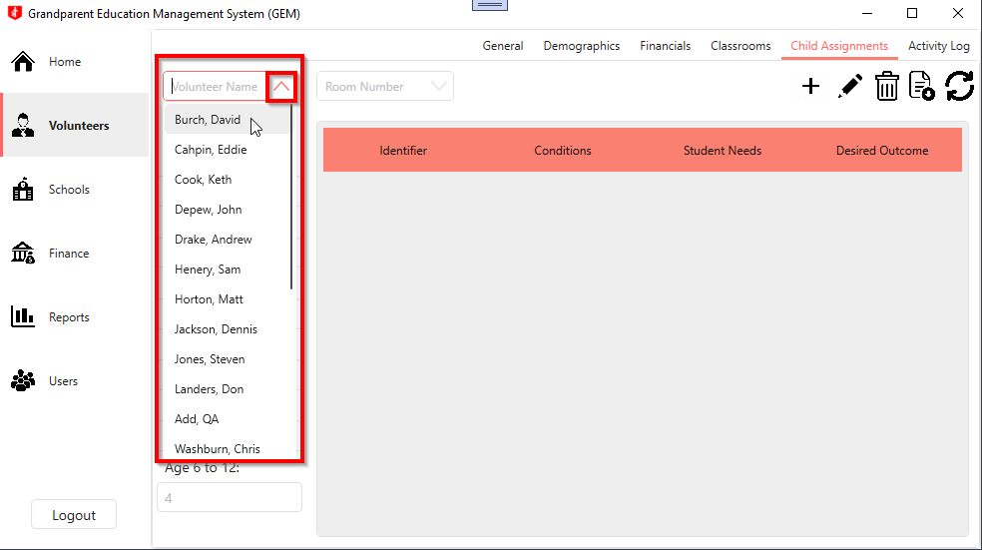

1. Click the Add icon.

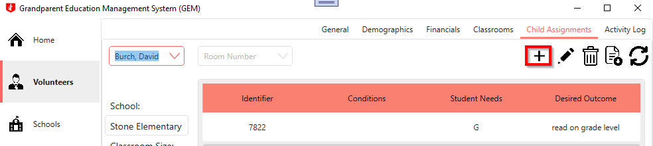

1. Click the Add Condition tab.

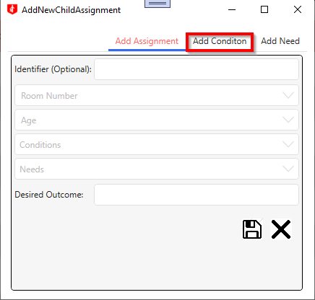

1. Fill out the Condition and Abbreviation text boxes.

1. Click the Save icon.

**Note: Click the Cancel icon to discard the changes and exit add mode.**

**Click the Yes button to** **discard the changes and exit add mode.**

**Click the No button to prevent the changes from being delete.**

### Add Student Need

1. Select volunteer from the Volunteer Name drop-down.



1. Click the Add icon.



1. Click the Add Need tab.

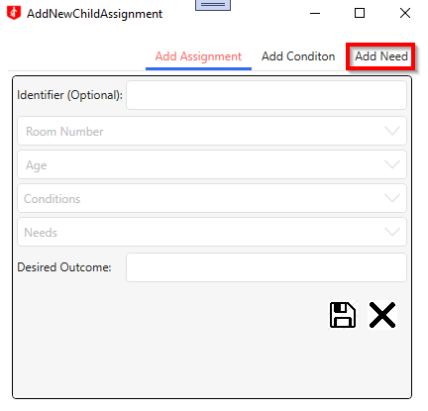

1. Fill out the Need and Abbreviation text boxes.

1. Click the save icon.

**Note: Click the Cancel icon to discard the changes and exit add mode.**

**Click the Yes button to** **discard the changes and exit add mode.**

**Click the No button to prevent the changes from being delete.**

### Remove Student from Volunteer

1. Select the volunteer from the Volunteer Name drop-down whose student assignment you want to edit.

1. Select the student’s room number from the Room Number drop-down.

1. Select the student you want to remove.

1. Click the delete icon.

1. Click the yes icon to confirm the delete.

**NOTE: Click the No icon to prevent the entry from being deleted.**

### View Volunteer’s Assigned Students

1. Select a volunteer from the Volunteer drop-down

### View Volunteer’s Assigned Students in Specific Classroom

1. Select a volunteer from the Volunteer drop-down.

1. Select a room number from the Room Number drop-down.

## Activity Log

### Page Summary

This page allows you to view a volunteer’s activity log, add a new entry to a log, delete an entry from a log and export activity log entries to Excel. There are two date fields that can be used to specify a date range to pull activity log entries from. The Select Volunteer drop-down allows you to select a volunteer to view entries specific to that volunteer. The date fields and Select Volunteer drop-down can be used together to view entries from a specific volunteer within a certain date range.

### Navigate to the Activity Log

1. Click the Volunteers Tab.

1. Click the Activity Log Tab.

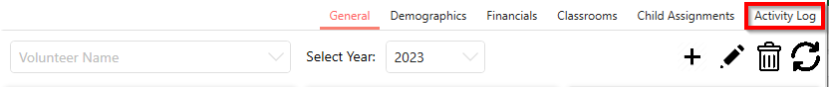

### View Volunteer’s Activity Log

1. Select the volunteer from the Select Volunteer drop-down to view the volunteer’s activity log.

### View Log Entries within Specific Dates

1. Enter a start date in the Start Date textbox. By default, this date is set to the first day of the current year.

1. Enter an end date in the End Date textbox. By default, this date is set to the last day of the current year.

### Add Log Entry

1. Click the volunteer from the Select Volunteer drop-down.

1. Click the Add icon.

1. Fill out the entry information. The required fields are outlined below.

1. Click the Save icon.

**Note: Click the Cancel icon to discard the changes and exit add mode.**

**Click the Yes button to** **discard the changes and exit add mode.**

**Click the No button to prevent the changes from being delete.**

### Edit Log Entry

1. Select the volunteer from the Select Volunteer drop-down.

1. Click the log entry to be edited.

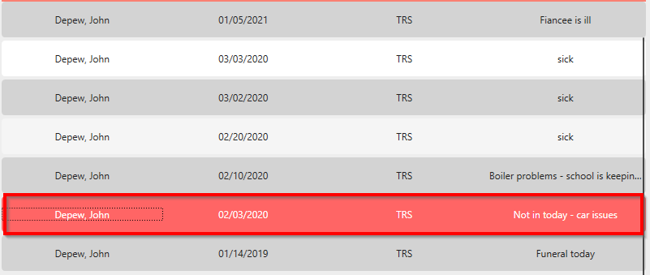

1. Click the Edit icon.

1. Update any of the editable fields outlined below.

1. Click the Save icon.

**Note: Click the Cancel icon to discard the changes and exit edit mode.**

**Click the Yes button to** **discard the changes and exit edit mode.**

**Click the No button to prevent the changes from being delete.**

### Delete Log Entry

1. Select the Volunteer to delete a log from.

1. Select the log entry to delete.



1. Click the Delete icon.

1. Click the Yes icon on the confirmation to delete the entry.

**Note: Click No icon to prevent the entry from being deleted.**

### Export Report to Excel

1. Select a Volunteer to export their activity logs to Microsoft Excel. If you do not select a specific volunteer, the activity logs for all the volunteers will be exported to Microsoft Excel.

1. Enter a start date in the Start Date textbox.

1. Enter an end date in the End Date textbox.

1. Click the Export icon.

1. Click Save icon.

**Note: Click the Cancel icon to discard the report.**

# Schools Tab

## All Schools

### Page Summary

This page allows you to see a list of all the schools in the program with information like the principal's name, the school's phone number, the active status of the school and a breakdown of the number of students and age ranges for each school. You can also add a new school and export site visitation sheets for all schools on this screen.

### Navigate to the All Schools

1. Click the Schools Tab.

1. Click the All Schools Tab

### Add New School

1. Click the Add icon to add a new school.

1. Enter the school’s information. All required fields are outlined below.

1. Click the Save icon.

**Note: Click the Cancel icon to discard the changes and exit add mode.**

**Click the Yes button to** **discard the changes and exit add mode.**

**Click the No button to prevent the changes from being delete.**

### Edit Specific School

1. Select the school to edit.

1. Click Edit icon.

1. Update any of the editable fields outlined below.

1. Click the Save icon.

**Note: Click the Cancel icon to discard the changes and exit add mode.**

**Click the Yes button to** **discard the changes and exit add mode.**

**Click the No button to prevent the changes from being delete.**

### Edit School Hours

1. Select the school to edit.

1. Click Edit icon.

1. Click Edit Time toggle.

1. Update Start Time.

1. Update End Time.

1. Click Save icon.

1. Click Save icon.

**Note: Click the Cancel icon to discard the changes and exit add mode.**

**Click the Yes button to** **discard the changes and exit add mode.**

**Click the No button to prevent the changes from being delete.**

### View Only Active Schools

1. Click the Active Schools checkbox.

### Export All Schools General Information to Excel

1. Click the Export icon.

1. Click Save icon.

**Note: Click the Cancel icon to discard the report.**

### Export All Cite Visitation Sheets to Word

1. Click the Export icon.

### Export Specific School’s Cite Visitation Sheets to Word

1. Select the school to export visitation sheet for.

1. Click the Export icon.

## Per School

### Page Summary

This page allows you to view the information for a specific school as well as the volunteers that are assigned to the school. On this page, the school’s information can also be edited and the site visitation sheet for the specific school can be exported.

### Navigate to Per School Page

1. Click the Schools Tab.

1. Click Per School Tab.

### Edit Specific School

1. Select the school to edit from the Select School drop-down.

1. Click Edit icon.

1. Update any of the editable fields outlined below.

1. Click the Save icon.

**Note: Click the Cancel icon to discard the changes and exit edit mode.**

**Click the Yes button to** **discard the changes and exit edit mode.**

**Click the No button to prevent the changes from being delete.**

### Make School Inactive

1. Select the school from the Select School drop-down.

1. Click Edit icon.

1. Click the Status toggle.

1. Click Save icon.



**Note: Click the Cancel icon to discard the changes and exit edit mode.**

**Click the Yes button to** **discard the changes and exit edit mode.**

**Click the No button to prevent the changes from being delete.**

### Edit School Times

1. Select the school to edit from the Schools drop-down.

1. Click the Edit icon.

1. Click the Edit Time toggle.

1. Update the Start Time.

1. Update the End Time.

1. Click the Save button.

1. Click the Save icon.

**Note: Click the Cancel icon to discard the changes and exit edit mode.**

**Click the Yes button to** **discard the changes and exit edit mode.**

**Click the No button to prevent the changes from being delete.**

### Delete School

1. Select the school from the Select School drop-down.

1. Click the Delete icon.

1. Click the Yes icon to confirm deletion.

**Note: Click the No icon to prevent the school from being deleted.**

### View Specific School Information

1. Select the school to view from the Select School drop-down.

### Export Specific School Information

1. Select the school from the Select School drop-down.

1. Click Export icon.

1. Click Save icon.

**Note: Click the Cancel icon to discard the report.**

# Finance Tab

## General

### Page Summary

This page allows you to view the school cost share amounts as well as all the in-kind amounts for a specific year. The year, in-kind type, and type of year can all be filtered. On this page a cost share amount can be added or edited, and an in-kind amount can be added or edited.

### Navigate to General Page

1. Click on the Finance Tab

1. Click on the General Tab

### View Specific Year’s Cost Share Data

1. Click on the Select Year dropdown to filter out a specific year’s cost share data.

Add Quarterly Cost Share Amount

1. Click the Add icon.

1. Enter all the cost share information.

1. Click the Save icon.

**Note: Click the Cancel icon to discard the changes and exit add mode.**

**Click the Yes button to** **discard the changes and exit add mode.**

**Click the No button to prevent the changes from being delete.**

### Edit Quarterly Cost Share Amount

1. Click the Cost Share you want to edit.

1. Click the Edit icon.

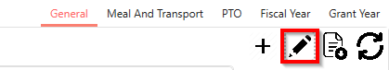

1. Update any of the editable fields outlined below.

1. Click the Save icon to save the changes made.

**Note: Click the Cancel icon to discard the changes and exit edit mode.**

**Click the Yes button to** **discard the changes and exit edit mode.**

**Click the No button to prevent the changes from being delete.**

### Delete Quarterly Cost Share Amount

1. Select the Cost Share to be deleted.

1. Click the Edit icon.

1. Click the Delete icon.

1. Click the Yes button to confirm the deletion.

**Note: Click the No button to prevent the cost share amount from being deleted.**

### View Specific In-Kind Expense Type

1. Select the expense type to view from the In-Kind Expense Type drop-down.

### View In-Kind Expense Year Range

1. Select year range from Year Range drop-down.

### View Type Year

1. Select either grant or fiscal from the Grant/Fiscal drop-down.

### Filter By Donor

1. Select volunteer name from Name drop-down.

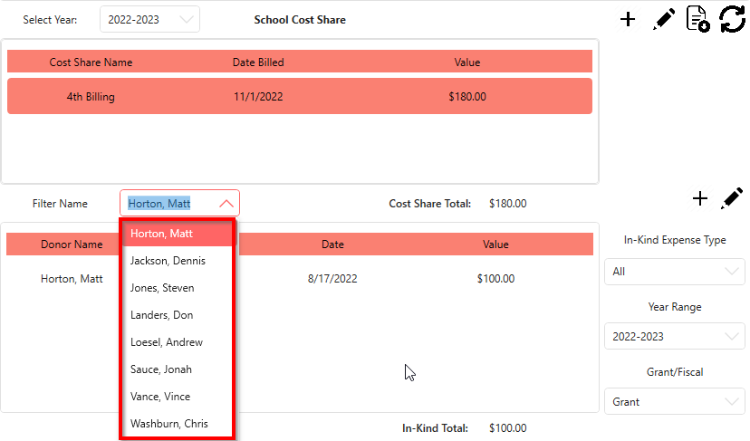

### Add New In-Kind Expense

1. Click Add icon.

1. Enter the expense information. All required fields are outlined below.

1. Click the Save icon.

**Note: Click the Cancel icon to discard the changes and exit add mode.**

**Click the Confirm Icon to** **discard the changes and exit add mode.**

**Click the Cancel Icon to prevent the changes from being delete.**

**Note: When entering a Donation, the Donor Name field requires a manual entry.**

### Edit In-Kind Expense

1. Select Expense to edit.

1. Click the Edit icon.

1. Update any of the editable fields outlined below.

1. Click the Save icon to persist your changes.

**Note: Click the Cancel icon to discard the changes and exit edit mode.**

**Click the Confirm Icon to** **discard the changes and exit edit mode.**

**Click the Cancel Icon to prevent the changes from being delete.**

## 

## Meal and Transport

### Page Summary

This page allows you to view all volunteer’s meals and transportation data for a specific year and month. On this page a volunteer’s data can be edited and the information can be exported to Excel.

### Navigate to Meal and Transport Page

1. Click on the Finance Tab

1. Click on the Meal and Transport Tab

### View Specific Date’s Information

1. Select a year from the Select Year Range drop-down.

1. Select a month from the Select Month drop-down.

### View Specific Volunteer's Meal and Transportation Information

1. Select a volunteer from the Filter Name drop-down.

### Edit Meals and Transportation Information

1. Click the Edit icon.

1. Select volunteer to edit.

1. Update any of the editable fields outlined below.

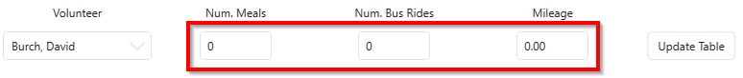

1. Click the Update Table icon.

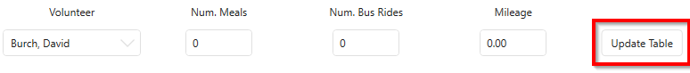

1. Click the Save icon to persist your changes.

**Note: Click the Cancel icon to discard the changes and exit edit mode.**

**Click the Confirm Icon to** **discard the changes and exit edit mode.**

**Click the Cancel Icon to prevent the changes from being delete.**

### Export Meals and Transport Information to Excel

1. Select month and year combination for data to be exported.

1. Select volunteer name to export only one volunteer’s data.

1. Click Export icon.

1. Click Save icon.

**Note: Click the Cancel discard report.**

## PTO

### Page Summary

This page allows you to view all volunteer’s PTO data for a specific year and month. On this page a volunteer’s data can be edited and the information can be exported to Excel.

### Navigate to PTO Page

1. Click the Finance Tab

1. Click the PTO Tab.

### View Specific Date’s PTO Information

1. Select a year from the Year drop-down.

1. Select a month from the Month drop-down.

### View Specific Volunteer PTO

1. Type volunteer’s name into Search Volunteer textbox.

### Edit Volunteer PTO Information

1. Click the Edit icon.

1. Select volunteer to edit.

1. Update any of the editable fields outlined below.

1. Click the Add To Table icon.

1. Click the Save icon to persist your changes.

**Note: Click the Cancel icon to discard the changes and exit edit mode.**

**Click the Confirm Icon to** **discard the changes and exit edit mode.**

**Click the Cancel Icon to prevent the changes from being delete.**

### Export PTO Information to Excel

1. Select month and year combination for data to be exported.

1. Type a volunteer’s name to export only one volunteer’s data.

1. Click Export icon.

1. Click Save icon.

**Note: Click the Cancel discard report.**

## Fiscal Year

### Page Summary

This page allows you to view the Meal-In-Kind, Volunteer Milage, Year to Date In-Kind, Bus Transportation data for a specific fiscal year. You can also view a further broken-down report of any of the categories and can export the data to Excel.

### Navigate to Fiscal Year

1. Click the Finance Tab.

1. Click the Fiscal Year Tab.

### View Specific Year Range

1. Select year range from the Fiscal Date Range drop-down.

### 

### View Category Breakdown

1. Click the Search icon for any of the four of the categories to view them in full screen.

**Note: Click the Minimize icon to return to the main view.**

### Export Category Breakdown

1. Click the Search icon to expand the category you want to export.

1. Enter a start date in the Start Date textbox.

1. Enter an end date in the End Date textbox.

1. Click the Export icon.

1. Click the Save button.

**Note: Click the Cancel button to discard the report.**

### View Specific Date in Category Breakdown

1. Enter a start date in the Start Date textbox.

1. Enter an end date in the End Date textbox.

### Export Quarterly Fiscal Year Information

1. Click the Export icon.

1. Click the Save button.

**Note: Click the Cancel button to discard the report.**

## Grant Year

### Page Summary

This page allows you to view the Meal-In-Kind, Volunteer Milage, Year to Date In-Kind, Bus Transportation data for a specific grant year. You can also view a further broken-down report of any of the categories and can export the data to Excel.

### Navigate to Grant Year Page

1. Click the Finance Tab.

1. Click the Grant Year Tab.

### View Specific Year Range

1. Select year range from the Grant Date Range drop-down.

### View Category Breakdown

1. Click the Search icon for any of the four of the categories to view them in full screen.

**Note: Click the Minimize icon to return to the main view.**

### Export Category Breakdown

1. Click the Search icon to expand the category you want to export.

1. Enter a start date in the Start Date textbox.

1. Enter an end date in the End Date textbox.

1. Click the Export icon.

1. Click the Save button.

**Note: Click the Cancel button to discard the report.**

### View Specific Date in Category Breakdown

1. Enter a start date in the Start Date textbox.

1. Enter an end date in the End Date textbox.

### Export Quarterly Grant Year Information

1. Click the Export icon.

1. Click the Save button.

**Note: Click the Cancel button to discard the report.**

# Reports Tab

## Report Builder

### Page Summary

This page allows you to build custom reports with different volunteer, school, and financial information for current, former, active, and inactive volunteers. These reports can be sorted by date or by volunteer name. This page also allows you to save and use preset reports.

### Navigate to Report Builder Page

1. Click the Report Tab

1. Click the Report Builder Tab

### Build Custom Report

1. Select the value to sort the report by from the Sort By drop-down.

1. Select what type of volunteers should be included in the report.

1. Click the Select All Volunteers checkbox to get information for all volunteers for the build or choose a volunteer name from the Volunteer Name drop-down to get only their information for the build.

1. Enter a start date for when to start pulling information from for the build.

1. Enter an end date for when to stop pulling information from for the build. By default, this date is set to the current date.

1. Select the desired information to be added to the build.

1. Click the Move button.

1. Click the Generate Report button after all of the information has been added to the right panel of the page.

### Add Preset Report

1. Build the report you want to be saved as a preset.

1. Click the Add icon.

1. Enter the name for the report in the Preset Name textbox.

1. Click the Save icon.

**Note: Click the Cancel icon to discard the changes and exit add mode.**

**Click the Confirm Icon to** **discard the changes and exit add mode.**

**Click the Cancel Icon to prevent the changes from being delete.**

### Use Preset Report

1. Select the preset report from the Presets drop-down.

1. Click the Generate Report button.

### Edit Preset Name

1. Select the preset report from the Presets drop-down.

1. Click the Edit icon.



1. Update the preset’s name.

1. Click the Save icon.

**Note: Click the Cancel icon to discard the changes and exit edit mode.**

**Click the Confirm Icon to** **discard the changes and exit edit mode.**

**Click the Cancel Icon to prevent the changes from being delete.**

### Delete Preset

1. Select the preset report from the Presets drop-down.

1. Click the Delete icon.



1. Click the Confirm button to confirm that you wish to delete the preset.

**Note: Click the Cancel icon to prevent the preset from being deleted.**

## 

## Annual Check

### Page Summary

This page allows you to view all volunteers’ annual check information. You can filter by only current volunteers and by volunteers who are missing documentation. Each volunteers’ information can be expanded to also see the one-time checks for the volunteer.

### Navigate to Annual Check Page

1. Click on the Reports tab.  
   Graphical user interface, text, application

   Description automatically generated
2. Click on the Annual Check tab.  
   A picture containing text

   Description automatically generated

### View Current Volunteers

1. Click the Current Volunteers toggle switch to on.

### View Volunteer’s Missing Documentation

1. Click the Missing Documentation toggle switch on. Graphical user interface

   Description automatically generated with low confidence

### View Volunteer’s Check Information

1. Click the drop-down of the Volunteer whose information you want to check.  
   Graphical user interface, application, Word

   Description automatically generated

## 

## Volunteer Information

### Page Summary

This page allows you to view and edit the general demographic information for all volunteers. On this page you can also filter by a specific volunteer or by a specific status type.

### Navigate to Volunteer Information Page

1. Click on the Reports Tab

1. Click on the Volunteer Info Tab

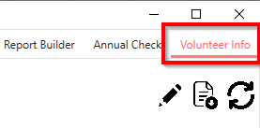

### Edit Volunteer Information

1. Select volunteer to edit.

1. Click Edit icon.

1. Update any of the editable fields outlined below.

1. Click Save icon.

**Note: Click the Cancel icon to discard the changes and exit edit mode.**



**Click the Yes button to** **discard the changes and exit edit mode.**

**Click the No button to prevent the changes from being delete.**

### View Specific Volunteer

1. Click on the Volunteer Name drop-down to view a specific volunteer’s information.

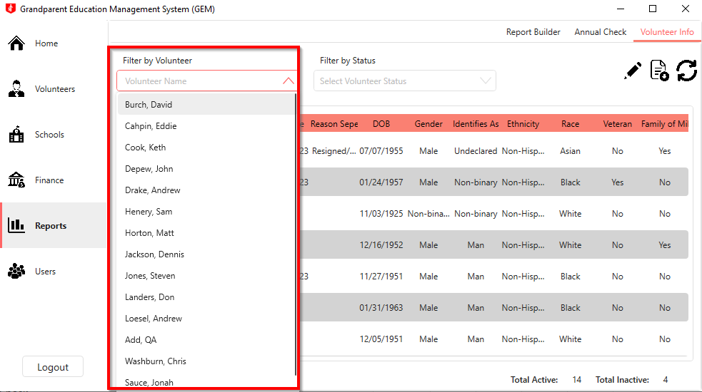

### View Volunteers Based on Status

1. Select a status from the Volunteer Status drop-down to view volunteer’s information based on status.

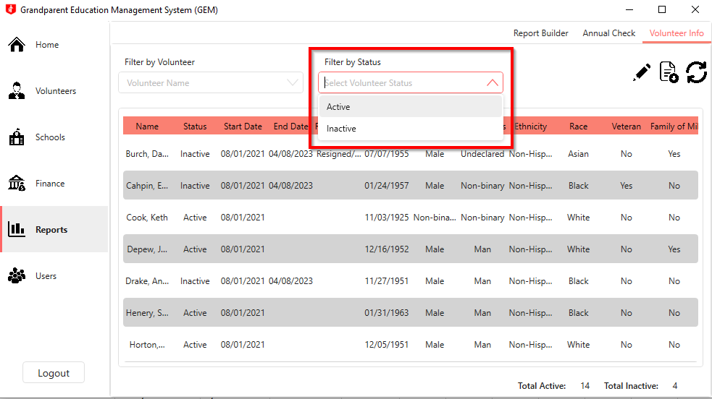

### Export Volunteer Information to Excel

1. Select a volunteer’s name from the Volunteer Name drop-down to export only one volunteer’s information to Microsoft Excel, otherwise all of the volunteer’s information will be exported to Microsoft Excel.

1. Select a volunteer status from the Select Volunteer Status drop-down to export only inactive or active volunteer’s information to Microsoft Excel.

1. Click the Export icon.

1. Click the Save button.

**Note: Click the Cancel button to discard the report.**

# Users Tab

## Users

### Page Summary

This page allows you to view, edit or add users to the system only if your user account has administration privileges. Through this screen you can update a user’s password or change someone’s administration privileges as well as update rates, add items to categories, reset child assignments and add a new year’s stipend amount.

### Navigate to the User Tab

1. Click on the Users Tab.

1. Click on the Users Tab.

### Add New User

1. Click on the Add icon.

1. Enter the user information. The required fields are outlined below.

**Note:**

1. Password must be longer than 8 characters.
2. Password must contain at least 1 capital letter.
3. Password must contain at least 1 number.
4. Password must contain at least 1 of the following special characters: !@#%-_?&*%
5. Click the Save icon when done.

**Note: Click the Cancel icon to discard the changes and exit add mode.**

**Click the Yes button to** **discard the changes and exit add mode.**

**Click the No button to prevent the changes from being delete.**

### Edit User Info

1. Select a user from the list.

1. Click the Edit icon.

1. Update any of the editable fields outlined below.

**Note:**

1. Password must be longer than 8 characters.
2. Password must contain at least 1 capital letter.
3. Password must contain at least 1 number.
4. Password must contain at least 1 of the following special characters: !@#%-_?&*%
5. Click the Save icon to persist your changes.

**Note: Click the Cancel icon to discard the changes and exit edit mode.**

**Click the Yes button to** **discard the changes and exit edit mode.**

**Click the No button to prevent the changes from being delete.**

### Delete User

1. Select a user from the list.

1. Click the Delete icon.

1. Click the Yes icon to confirm the deletion.

**Note: Click the No icon to prevent preset from being deleted.**

## Admin Tasks

### Page Summary

This page allows you to add new items to different categories, add a deleted volunteer back into the system, modify rates and meal or mileage values, enter grant year stipend and remove all students assigned to all volunteers.

### Navigate to the Admin Tasks Tab

1. Click the Users Tab.

1. Click the Admin Tasks Tab.

### Add Item to Category

1. Click the radio button for the category you want to add a new item to.

1. Type the new item into the Add New textbox.

1. Click the Add button.

### Add Temporary Information Field

1. Click on the Temp Info radio button to enter in a temporary information Graphical user interface, application

   Description automatically generated
2. Enter the temp info field name into the Add New textbox.

1. Select whether it will be a Date entry or a Checkbox entry.

1. Click the Add button.

### Delete Category Item

1. Click the radio button for the category you want to delete an item from.

1. Click the Delete icon next to the item to be deleted.

1. Click the Yes button to confirm the item is to be deleted.

**Note: Click the No button to prevent the item from being deleted.**

### Recover Deleted Volunteer

1. Click the Add icon next to the volunteer you want added back into the system.

### Edit Student Needs

1. Click the Edit icon next to the need you want to update.

1. Update any of the editable fields outlined below that you wish to edit.

1. Click the Save icon.

**Note: Click the Cancel icon to discard the changes and exit edit mode.**

**Click the Yes button to** **discard the changes and exit edit mode.**

**Click the No button to prevent the changes from being delete.**

### Delete Student Needs

1. Click the Delete icon next to the need you want to remove.

1. Click the Yes button to confirm the need is to be deleted.

**Note: Click the No button to prevent the need from being deleted.**

### Edit Student Conditions

1. Click the Edit icon next to the condition you want to update.

1. Update any of the editable fields outlined below that you wish to edit.

1. Click the Save icon.

**Note: Click the Cancel icon to discard the changes and exit edit mode.**

**Click the Yes button to** **discard the changes and exit edit mode.**

**Click the No button to prevent the changes from being delete.**

### Delete Student Conditions

1. Click the Delete icon next to the condition you want to remove.

1. Click the Yes button to confirm the condition is to be deleted.

**Note: Click the No button to prevent the condition from being deleted.**

### Edit Rates

1. Update any of the editable rate fields outlined below.

1. Click the corresponing Save button to the changed field.

### 

### Set Grant Year Stipend

1. Enter the grant year start date.

1. Enter in the Grant Stipend amount.

1. Click the Set Total Grant Stipend amount button.

### Delete All Students Assigned to Volunteers

1. Click the Reset Child Assignments button to delete all students assigned to volunteers.

1. Click the Yes button.

**Note: Click the No button to prevent the students from being deleted.**

